##### MINI SHOPPING BAG

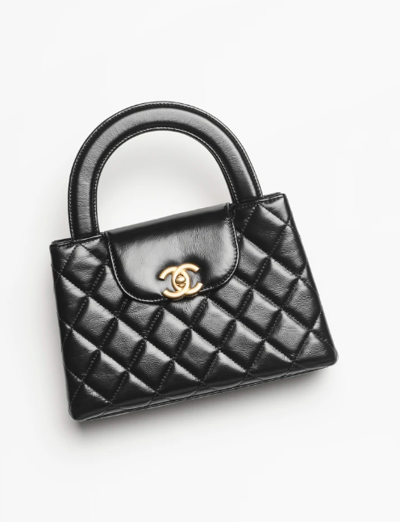  
The term "Mini Shopping Bag" typically refers to a smaller version of the classic shopping bag, often used as a stylish and practical accessory for everyday use. These bags are usually compact and lightweight, designed to carry essentials such as a wallet, phone, keys, and a few small items while on the go.

Mini shopping bags come in various styles, materials, and designs to suit different preferences and occasions. They can be made from leather, canvas, nylon, or other durable materials, offering both functionality and fashion-forward aesthetics.

Some mini shopping bags feature adjustable shoulder straps or handles for easy carrying, while others may have additional pockets or compartments for better organization. They are available in a wide range of colors and patterns, allowing you to find the perfect bag to complement your personal style.

These bags are versatile and can be used for various purposes, such as running errands, going out for brunch, or attending casual gatherings. They offer the convenience of a larger shopping bag but in a more compact and portable size.

If you're interested in purchasing a mini shopping bag, you can explore options from popular fashion brands, department stores, or online retailers. Look for features that suit your needs and preferences, such as size, material, design, and functionality, to find the perfect mini shopping bag for you.